Paper Title
Masters of Engineering  Information Technology  A S M Saiem Solimullah  Matriculation Number:  a.solimullah@stud.fra-uas.de | Masters of Engineering  Information Technology  A S M Saiem Solimullah  Matriculation Number:  a.solimullah@stud.fra-uas.de

Abstract— The ultrasonic sensors which use high frequencies sound wave can be used to identify people or objects along with measuring distance. This sensor uses sound waves that are emitted, bounce off surrounding objects, and return to the sensor, which uses the time it takes for the sound waves to return to determine the distance. Red Pitaya is an open-source, multifunctional tool designed for education, research, and prototyping. Its web-based interface and compatibility with programming languages make it accessible for beginners and professionals alike.
Keywords—ADC, FFT, PSD, Savitzky-Golayn Filter, Multilayer Perceptron & SVM

Introduction
Technology these days is doing some amazing things, especially when it comes to figuring out if someone’s nearby or not, without requiring camera sensors or any kind of too expensive devices. This paper dives into the common feature-based work of ultrasound, which uses sound waves that are too high-pitched for humans to hear. Detection can be found by analyzing more smart systems when a person is nearby without needing to touch or watch them closely. Consider an IOT based, smart home that automatically adjusts the lights when someone walks in, or a robot that moves around without bumping into anyone, or even a safety system that alerts others if someone’s in a risky area, like near heavy machinery. Ultrasound is perfect for these kinds of applications because of its discreet and unwanted video recordings. Also, it works well in all kinds of environments whether it’s dark or messy. In medical research, using pulse ultrasound measurement different thing can be diagnosed like blood pressure [1]. This project is based on the FIUS Sonar Sensor device outputs, a device that measures these sound waves to detect different distance object or movement of the object. The distance (d_{FIUS}) to an object can be determined using the inbuilt feature or using machine learning techniques. For distance measuring feature, FIUS uses the time takes for the ultrasonic pulse to return. In this project the object type was person and static object(soft/hard). The FIUS is mounted about 40-50 cm above the ground, keeping an eye out for movement directly across its path. It’s already decent at measuring distances, but this analysis aims to make it even better particularly at distinguishing between a person and other static object, like a chair or a box. The main goal of this project is to measure the FIUS’s ability to detect the object and measure the distance of that object accurately and reliably. The steps include collecting and labeling ultrasonic echo data for different distance of the object, developing algorithms for echo detection, after measuring the distance apply supervised machine learning algorithms for object type detection based on the collected data features. And finally, implementing real-time sensor output based on detection results.

Litarature review
Before you begin to format your paper, first write and save the content as a separate text file. Complete all content and organizational editing before formatting. Please note sections A-D below for more information on proofreading, spelling and grammar.

Theoretical Background
Before you begin to format your paper, first write and In this project, we have used several components to assess the reliability and improve an object detecting sensor system. Here in this section, those element descriptions will be given over the necessary hardware, the programming language, and the machine learning technique that have been employed to create the model.

Red Pitaya Based FIUS sonar sensor:
Red pitaya is a stem lab board that can measure analog and digital signal. This has the ADC features which enables it to convert the analog signal into digital signal and vice versa. Red pitaya’s open-source hardware and software can be coupled with an easy-to-use web interface, which enhance data visualization and remote control. The sensor used for this project to measure the horizontal and perpendicular data has 16 general input and output physical ports along with an RJ45 socket connector for the Ethernet and an USB port. The red pitaya sensor can measure high range frequency signal. For this project, only 30 KHz to 50 KHz signal taken into account. 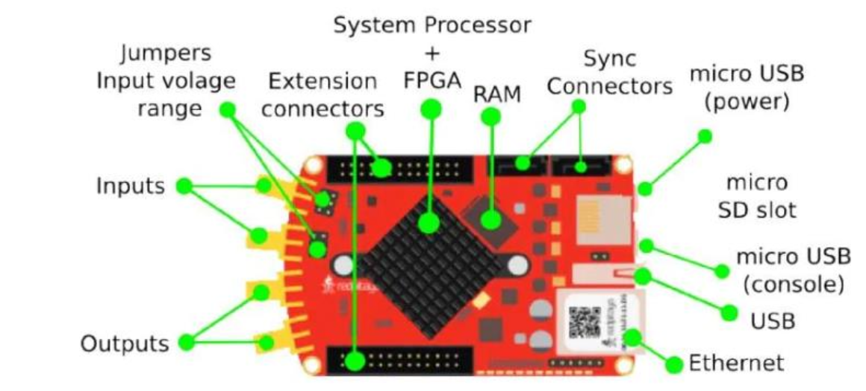
Figure 1: Red pitaya steam board configuration
The fully integrated ultrasonic sensor (FIUS) is a compact, high performance ultrasonic signal sensing device. Ultrasonic sensor basically uses ultrasonic waves to calculate the distance to an object. This device is commonly used in robotics, automation and proximity detection applications. This device worked based on the echolocation of the signal. The sensor emits high frequency signals and then receive the same signal, which then calculate the distance of the sensor received signal using the time to flight formula.
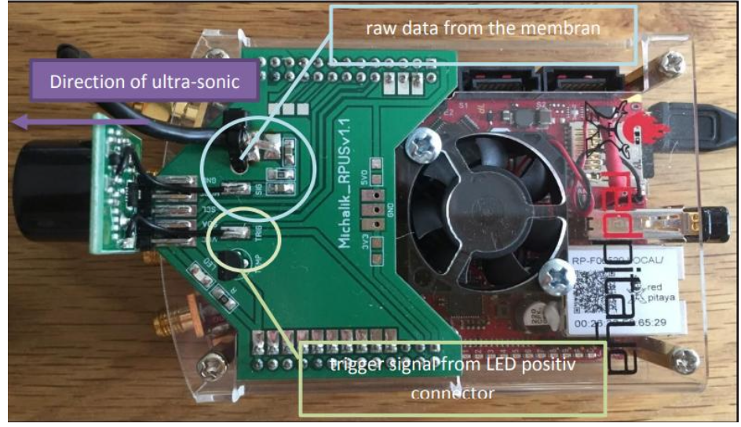
Figure 2: Red pitaya board’s hardware and sensors
After calculating the signal data, first eco can be easily detected for the object and then the distance of that object can be measured.

Eco Detection
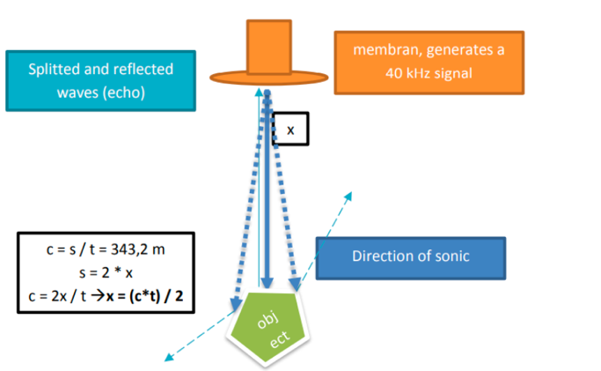
Eco detection is an important process to find the distance from the ultrasonic sonar sensor. It identifies the reflected sound waves that returns after hitting an object. From this reflected wave we can find the approximate distance of the object. Using this first eco detection process we have identified the distance of the object in our project.

.”

Figure 3: Distance measuring procedural calculation

Fast Fourier Transform:
FFT transform a signal from time domain to frequency domain which allows the analysis of the frequency component of the ultrasonic sound waves. We have applied autocorrelation function to the raw ADC signal which then transformed with FFT after applying a window to the data portion of the signal. This gives an output of power spectral density which helped to classify the signal later applied on the machine learning model.

ADC Data
The data we have found from the ultrasonic sensor is analog raw data. ADC samples this high frequency rate data and can convert it into digital form through FFT. These digital data frames then can be analyzed or classified using algorithm like MLP or SVM.

Savitzky-Golay filter
The Savitzky-Golayn (savgol) filter is a signal smoothing technique that reduces low signal noise while maintaining the key characteristics of the signal like peak and edges. It is useful for applications like ultrasonic sensing where clean signals are required without distorting unexpected shifts since it uses least squares to fit a polynomial to a changing window of data points. [savitzky] It is useful for echo detection, feature extraction, and signal preprocessing in both scientific and technical applications. In respect to simple moving averages, it preserves the signal's default structure.

Multilayer Perceptron (MLP) Classifier
MLP is a type of feed forward neural network consisting of inputs, hidden and output layers. It is trained via backpropagation algorithm and useful for complex pattern learning, signal analysis and data classification. We have used MLP classifier for finding object type from different pattern of the data. We have used two different types of MLP classifier for finding the object type and distance from the raw signal data.

Confusion Matrix
A confusion matrix is a table that shows us how well a classification model is performing is called a confusion matrix. It compares the predicted results of the model with the actual results. In our project we have analyzed the result of the performed model using this confusion matrix. This confusion matrix consists of four different elements as True Positive, True Negative, False Positive and False Negative.
- True Positive: When the expected and actual values are equal, we have a true positive case. This implies that even if the model predicted a positive outcome, the actual outcome is similarly positive.
- True Negative: When the expected value and the actual value are equal, the situation is said to be truly negative. However, in this case, the model's predicted and the actual outcome are both negative.
- False Positive: When the expected value matches an inaccurate value, this is known as a false positive. Type 1 prediction errors are the types that fall within this category.
- False Negative: When the expected value and the incorrect value match this is known as a false negative case. The actual value was positive, against the model's prediction that it would be negative. This is known as type 2 error.

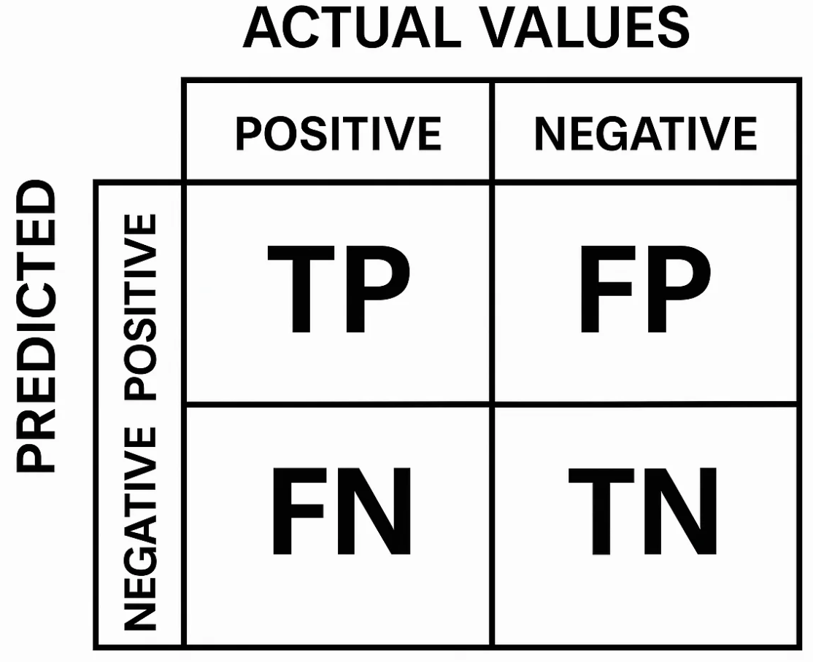
Figure 4: Confusion Matrix
Also using this confusion matrix, we have analyzed the result of different other measuring parameters like accuracy, precision, recall and F1 Score.
- Accuracy: How many predictions were correct in the dataset.
- Precision: How many predictions was accurate can be found through this matrix.
- Recall: How many true results we catch using the models.
- F1 Score: It defines a balance between precision and recall.

Methodology
FIUS sensor which used in this project mounted with the red pitaya at a height of 40-50cm above from the ground for measuring the distance of the object along with the object type. It is based on a field-programmable gate array (FPGA) and a dual-core ARM Cortex-A9 processor, which allows real-time signal processing and control.

Data Acquisition
In order to detect the object type, two different types of object data have been taken from the sensor in different distance. In dataset 1, 2 and 3, Almost 9000 data have been collected every time for several distance with different objects. The object type was person and a static box. This whole experiment was monitored in the FIUS Ultrasonic Sensor UI interfaces. For different distance reading 1000 signal data has been observed. For individual time series data, 50000 data point have been found from the time series signal along with 17 header information. Also, before started to take the data measurement of the sensor for the object, different distance has been marked for manual measurement of the distance data.

Darta Preprocessing
In order to find the information and features from the ADC signal found from the sensor, data need to be preprocessed. Later those preprocessed data were feeded to the machine learning model for better accuracy.

Data Labelling: After collecting the data from the sensor, raw data has been added with two different level columns as “Distance” and “Object”. On the distance column, the measurement of manual distance has been added and on the object column, object types of the data have been defined. For visualsing the proper data in the dataframe we added header title in the dataset which has been used in the s

Removing Header: The data found from the ultrasonic sensor has 50017 columns, in which 17 column is header information and 50000 column is time series data information. For finding the valid signal those headers were removed when preprocessed the signal data.

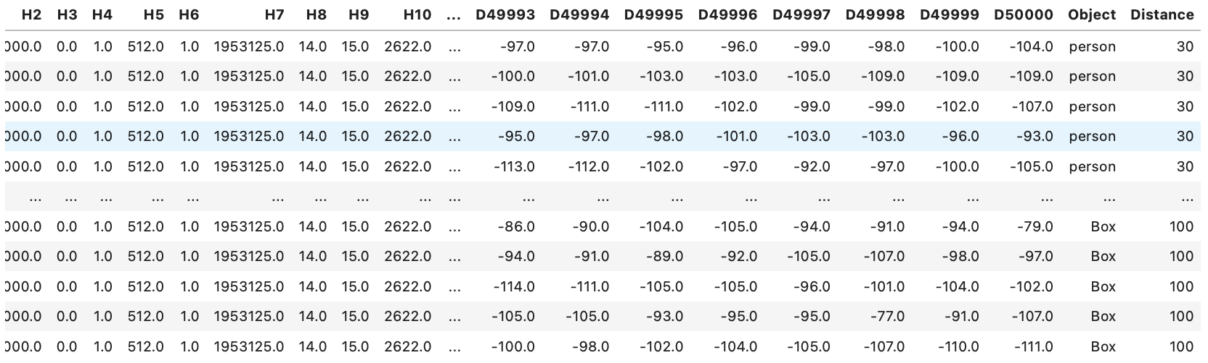

Remove Noisy Signal: For removing noisy signal we have applied an initial filter to the collected dataset for more clean signal using savgol filter.
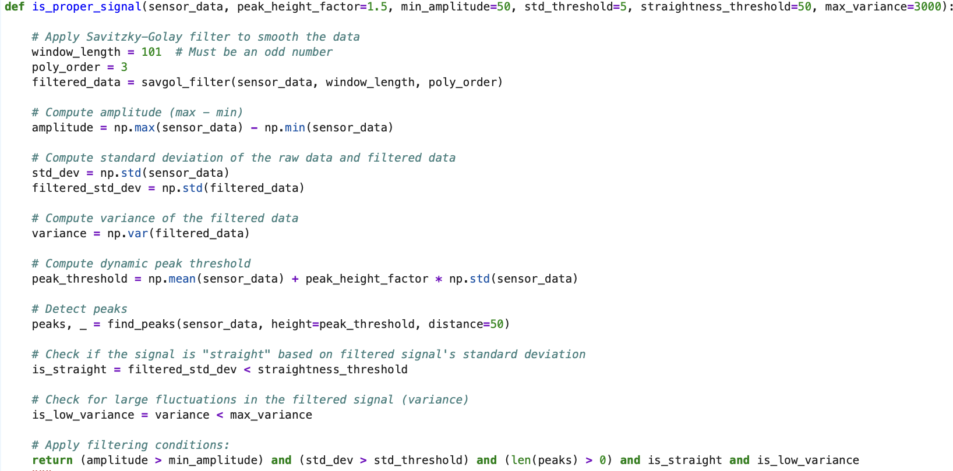

First Eco Detection: For finding the distance of the object from the sensor data, first we need to find the first echo of the signal. After finding the first echo of the signal distance of the data can be calculated and these calculated data has been later stored in the data frame as a separate column leveled as “First Echo Index”.

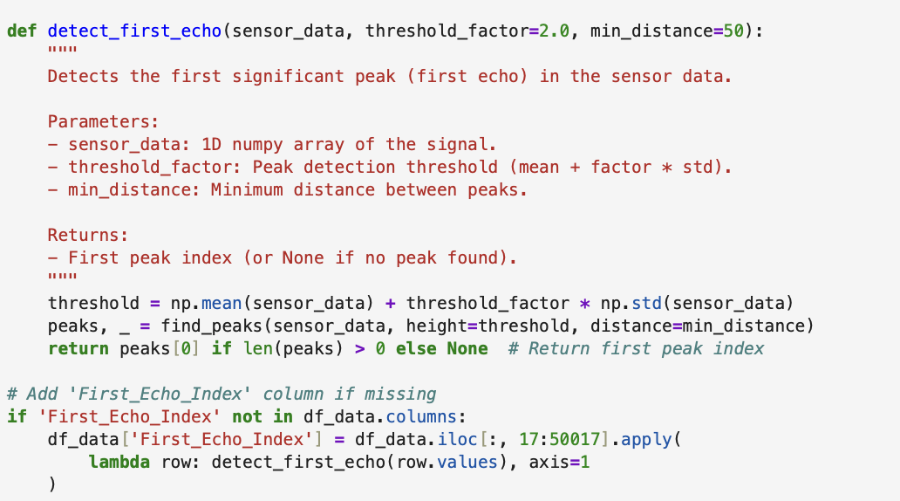

ACF and Windowed Signal: Autocorrelation function and window has been applied to the data to find the power spectral density of the signal. For finding this power spectral density, sampling frequency assumed to be 195317 Hz and the applied window size was 300 on the signal data. This PSD calculation has been done using welch method which is an inbuilt method for finding the PSD in the python. These PSD features then feed to the model for train and testing the data to find the object type and distance from the signal.

MLP Classifier & SVM:
As defined in the instructed document, we have used two different types of classifiers for building the model. One is multi-level-perceptron classifier and another one is SVM classifier. For finding the object type MLP classifier was SVM.

Acknowledgment (Heading 5)
The preferred spelling of the word “acknowledgment” in America is without an “e” after the “g”. Avoid the stilted expression “one of us (R. B. G.) thanks ...”. Instead, try “R. B. G. thanks...”. Put sponsor acknowledgments in the unnumbered footnote on the first page.

References

- G. Eason, B. Noble, and I. N. Sneddon, “On certain integrals of Lipschitz-Hankel type involving products of Bessel functions,” Phil. Trans. Roy. Soc. London, vol. A247, pp. 529–551, April 1955. (references)
- J. Clerk Maxwell, A Treatise on Electricity and Magnetism, 3rd ed., vol. 2. Oxford: Clarendon,

